Democrats have dramatically shifted their views of the US economy since the election 

The way Democrats view the economy has undergone a dramatic shift in the week since Donald Trump was elected president of the United States.

Gallup’s Economic Confidence Index, based on an average of how Americans view current economic conditions, registered a large shift among self-identified Democrats over a week time period following Election Day.

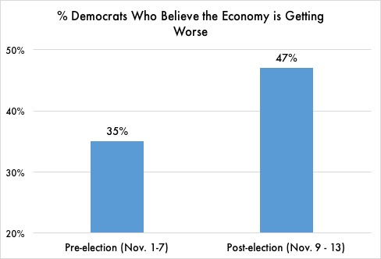

“Lagging economic confidence is mostly due to Democrats’ more negative evaluations after Donald Trump won the election,” said the release from Gallup. “Democrats had a more optimistic view of the economy — especially of its future direction — during President Barack Obama’s two terms.”

In fact, the proportion of Democrats saying the economy is getting worse increased from 35% in the preelection period to 47% after Trump was elected.

*Democrats became more pessimistic about the economy immediately following Trump’s election. Source: Gallup Polls, Nov. 1-13, 2016.*

It is important to note that despite the huge swing in Gallup’s polling, economic conditions – including rates of unemployment, inflation, and wage growth – have not changed over the past few weeks.

“Democrats are out of their minds if they think the economy is suddenly doing worse because of Trump,” said Susan Thomas, a retired schoolteacher from Harrisburg, PA who voted for the President in 2016. “He’s rescuing us from all the damage Obama did. Anyone who can’t see that is delusional.”

President Trump has frequently touted the economy’s performance under his administration, often tweeting out reports of the stock market hitting new highs. The White House has also balked at suggestions that former President Obama is responsible for the current state of the economy.